Ryan Smith

CIS 320

Iteration 5

**Windows Navigation Diagrams**

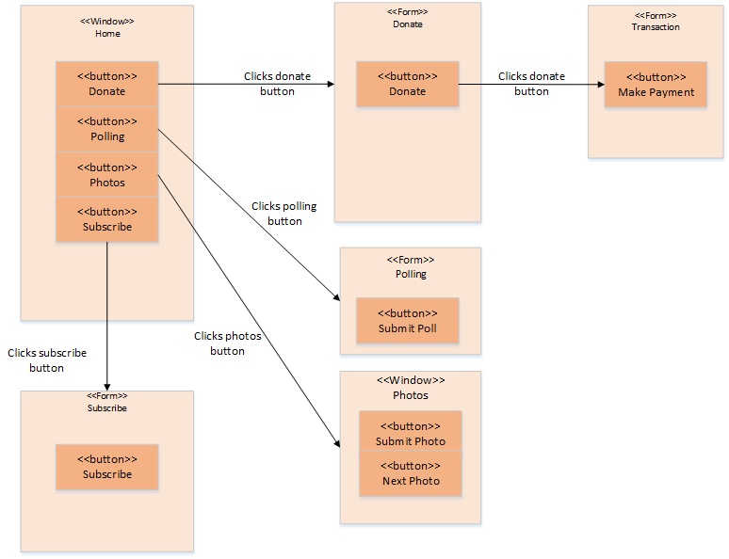

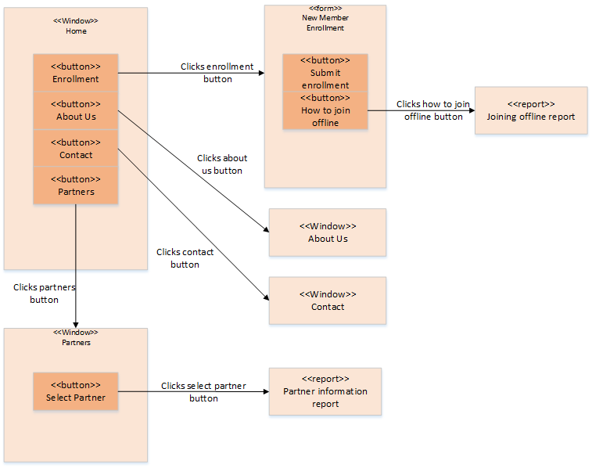

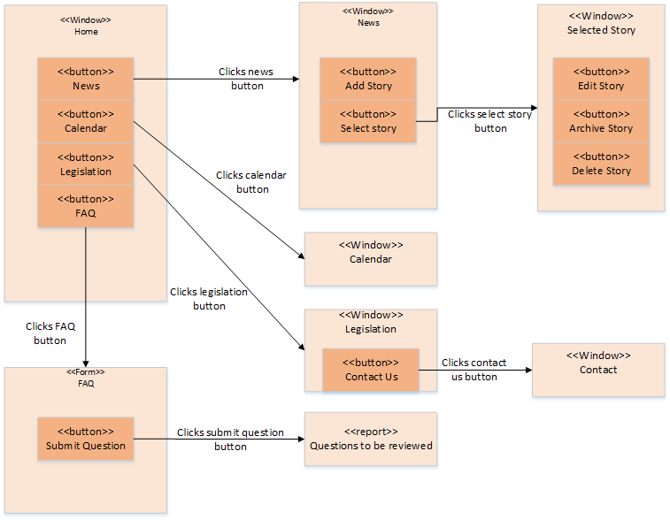

**Input Screen Layouts**

New Member Enrollment Form

This screen realizes the use case by allowing the user to enter all information necessary for them to join the KYHBPA online.

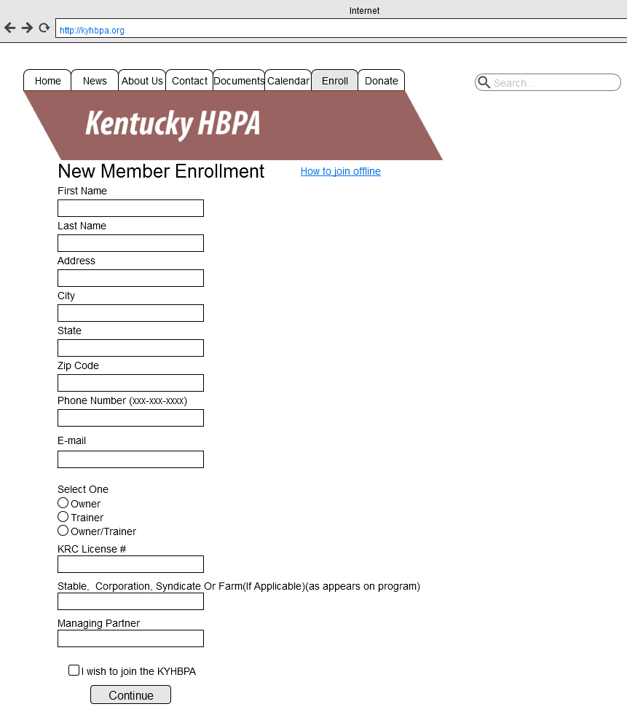

Polling Form

This screen realizes the use case by allowing a member to express their opinion on issues that are relevant to the KYHBPA.

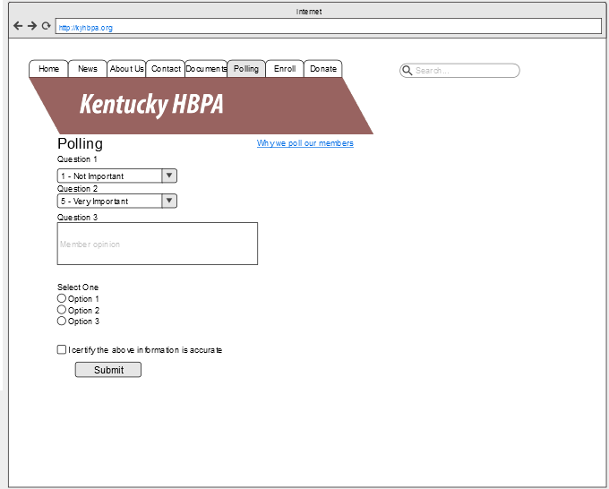

Subscribe Form

This screen realizes the use case by allowing a user to subscribe to the newsletter.

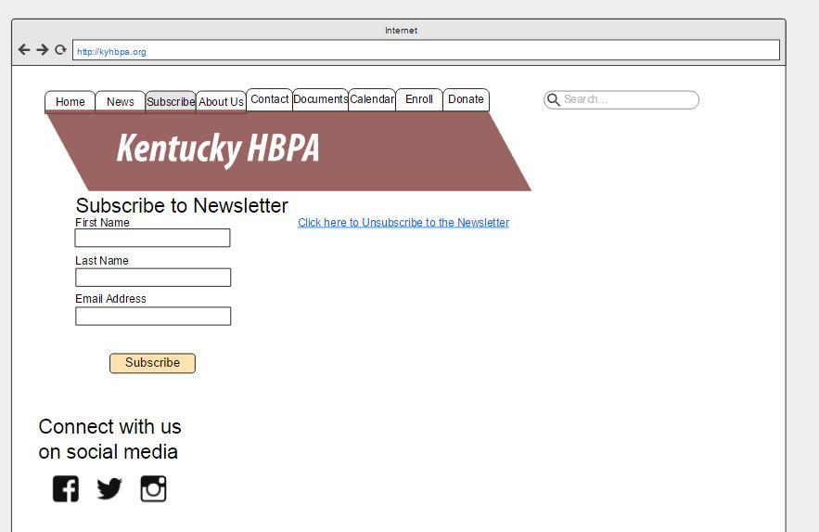

Donate Form

This screen realizes the use case by allowing a donor to make a donation online.

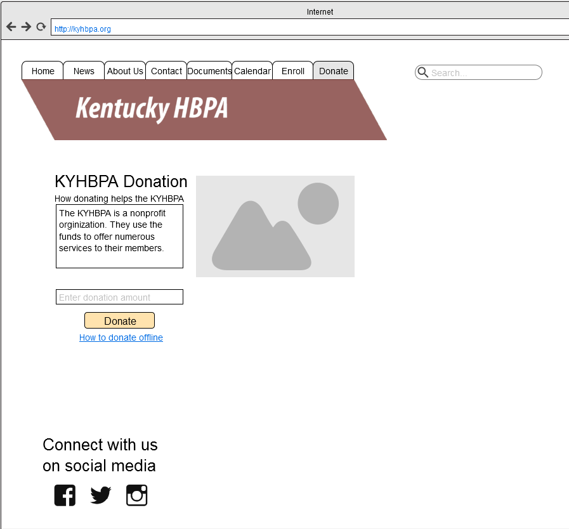

Transaction Form

This screen realizes the use case by allowing a payment to be made through an online transaction processing system.

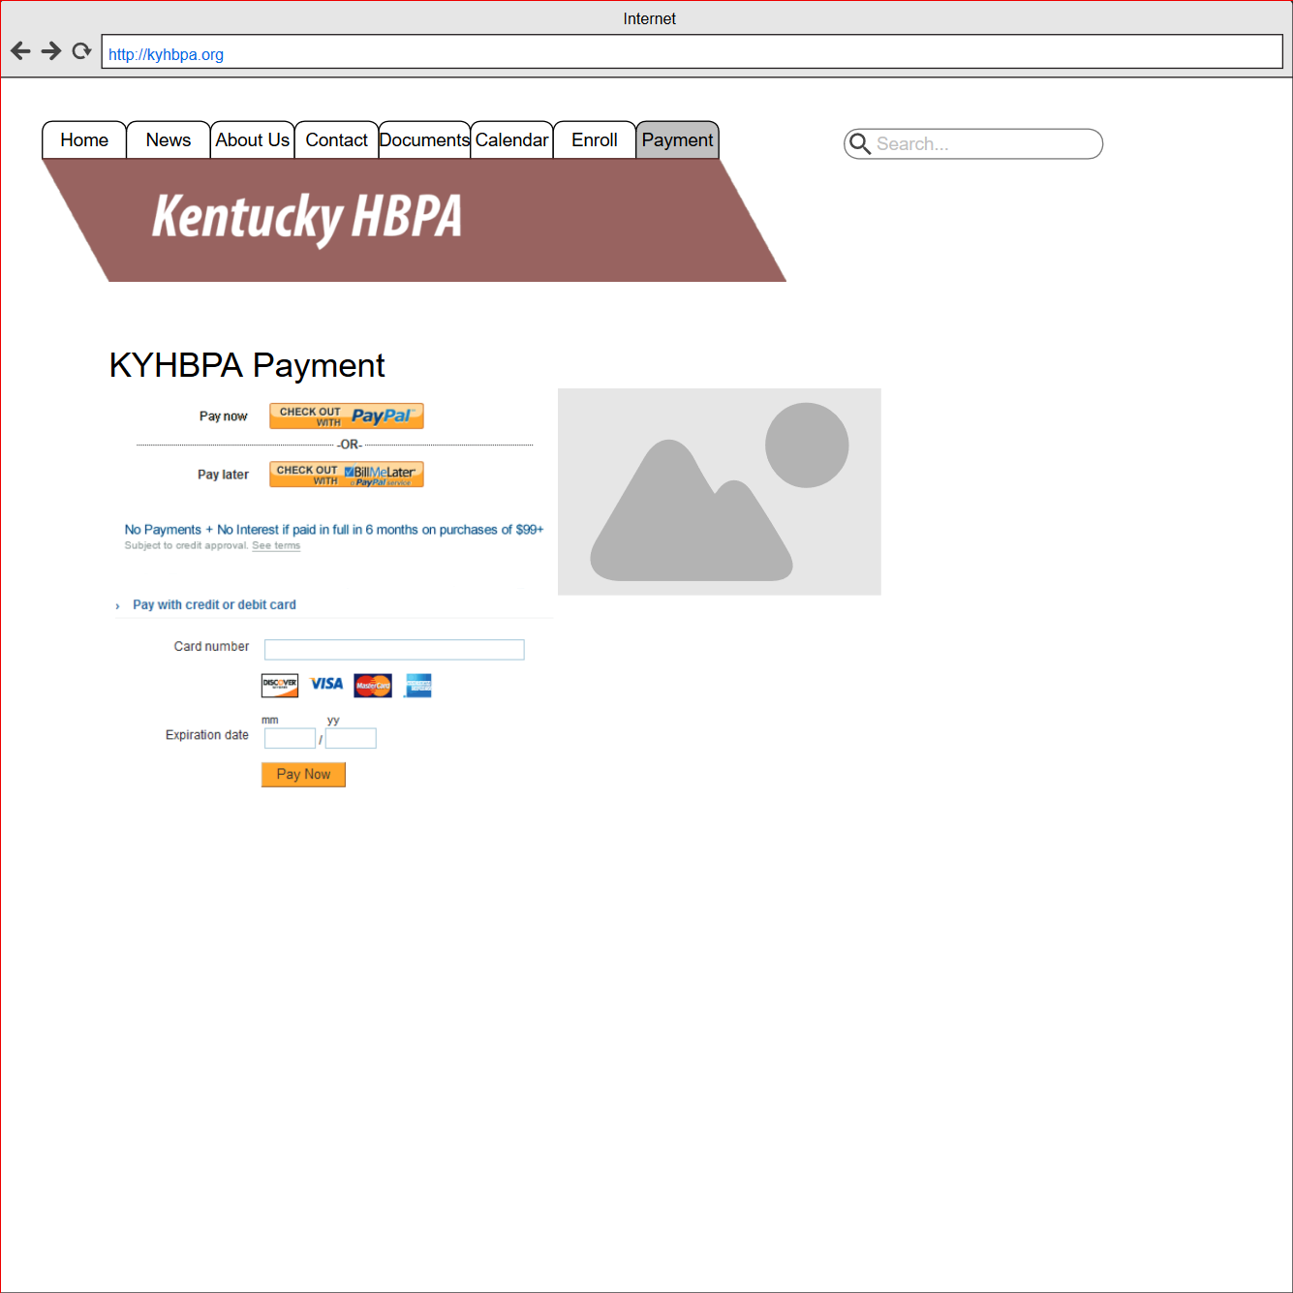

FAQ Form

This screen realizes the use case by allowing users to enter questions to be answered and review previously answered questions.

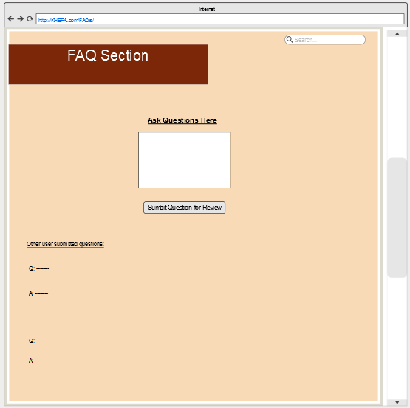

**Output Screen Layouts**

Joining Offline Report

This screen realizes the use case by providing information about how to join the KYHBPA offline.

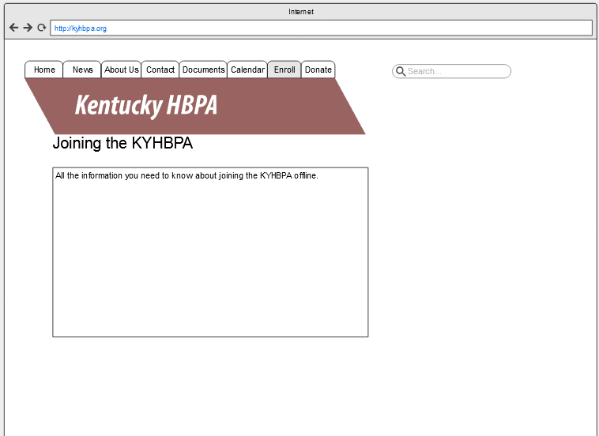

Partner Information Report

This screen realizes the use case by providing information about a selected partner.

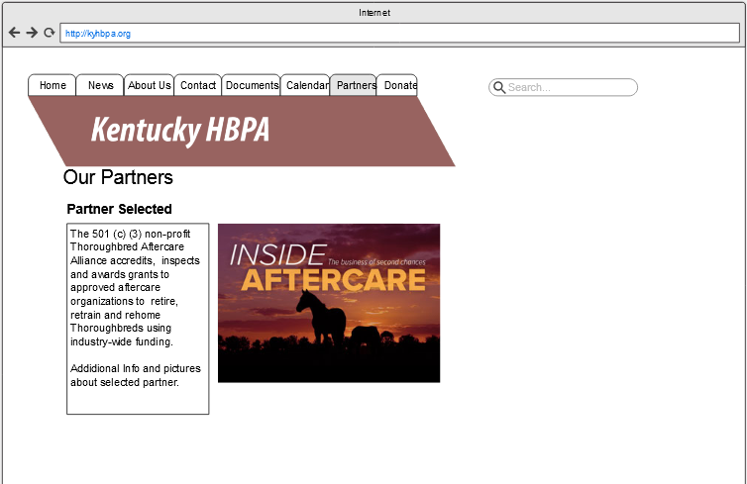

Contact Screen

This screen realizes the use case by providing all the information users may need to contact the KYHBPA.

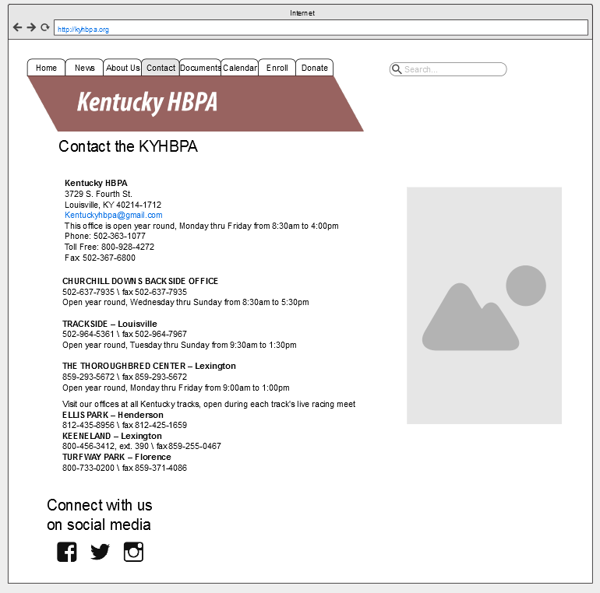

About Us Screen

This screen realizes the use case by providing information about the KYHBPA.

